Section 6

Mapping: How to set Geographical Roles

Right click the appropriate field and select the appropriate geographic role

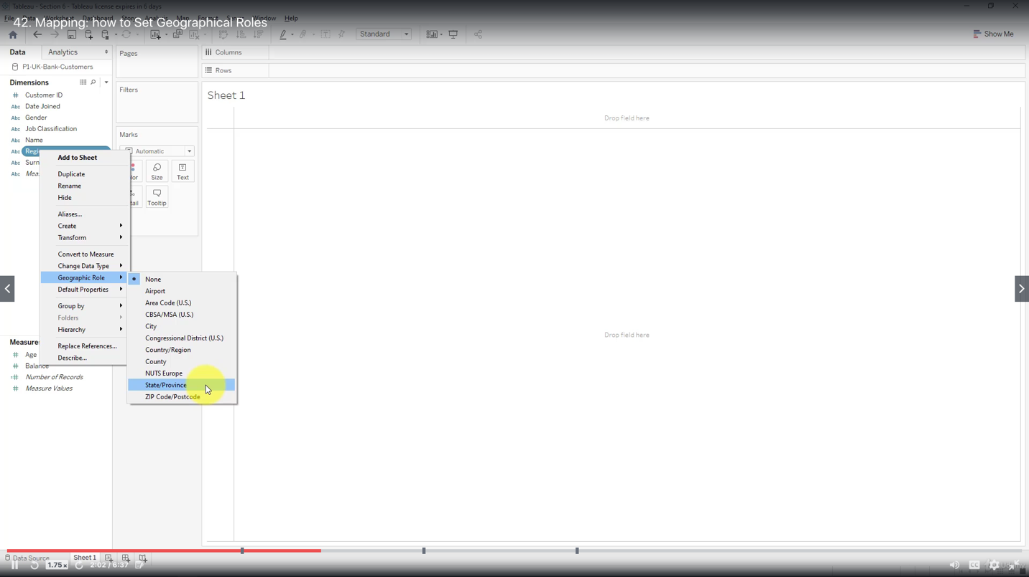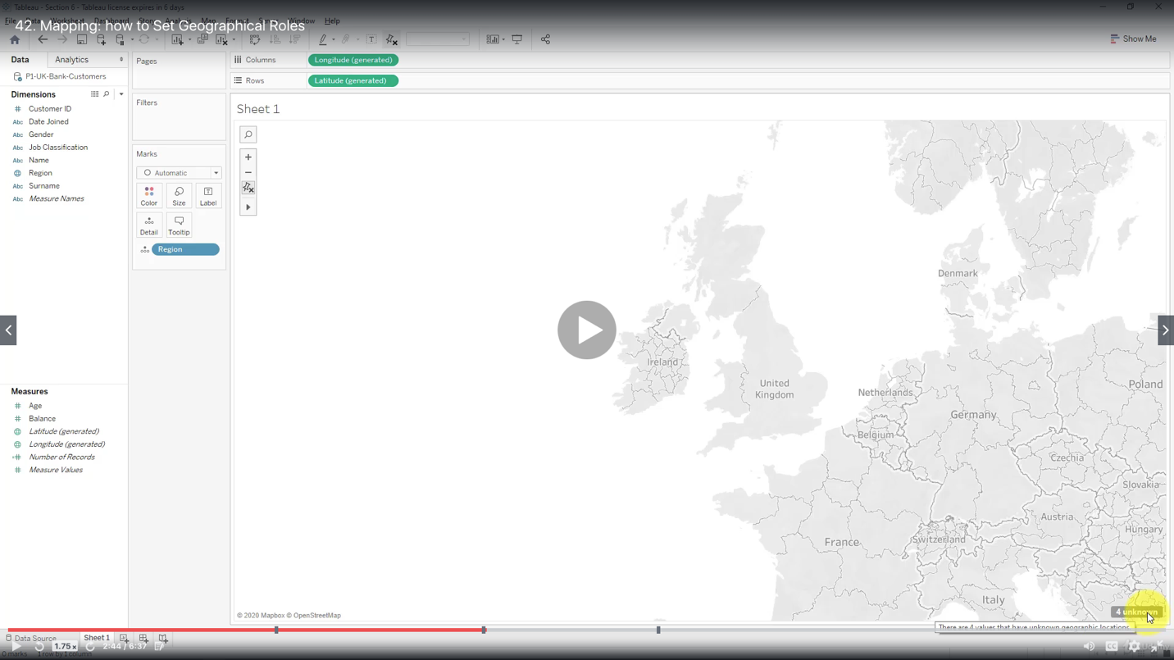

Click on unknown to edit locations

Specify country as United Kingdom (the default is United States)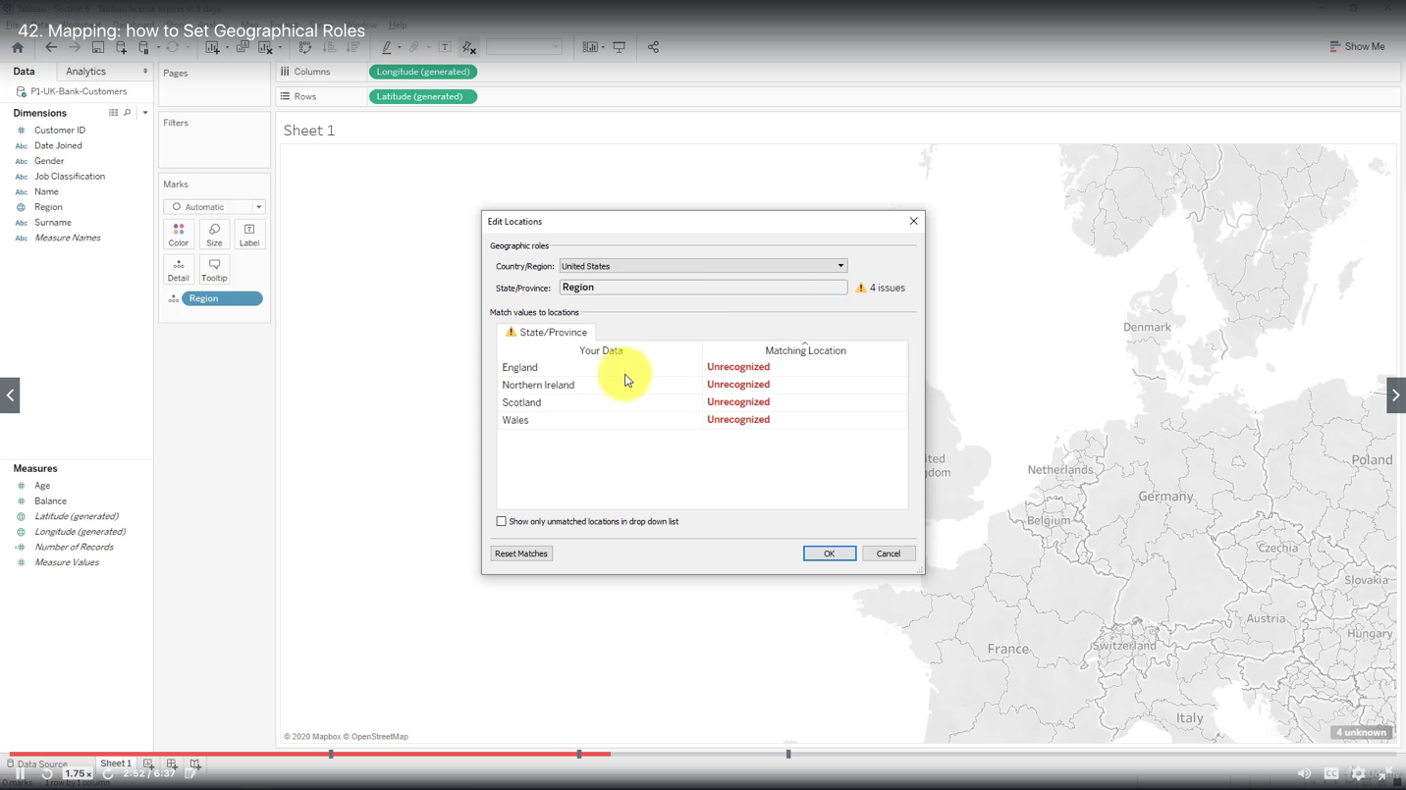

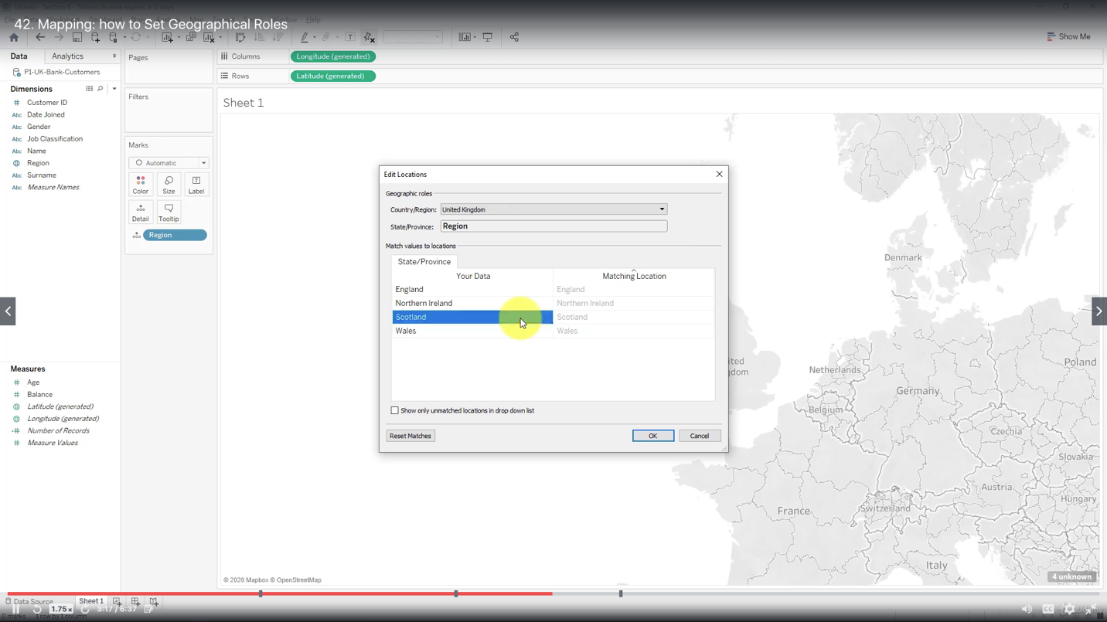

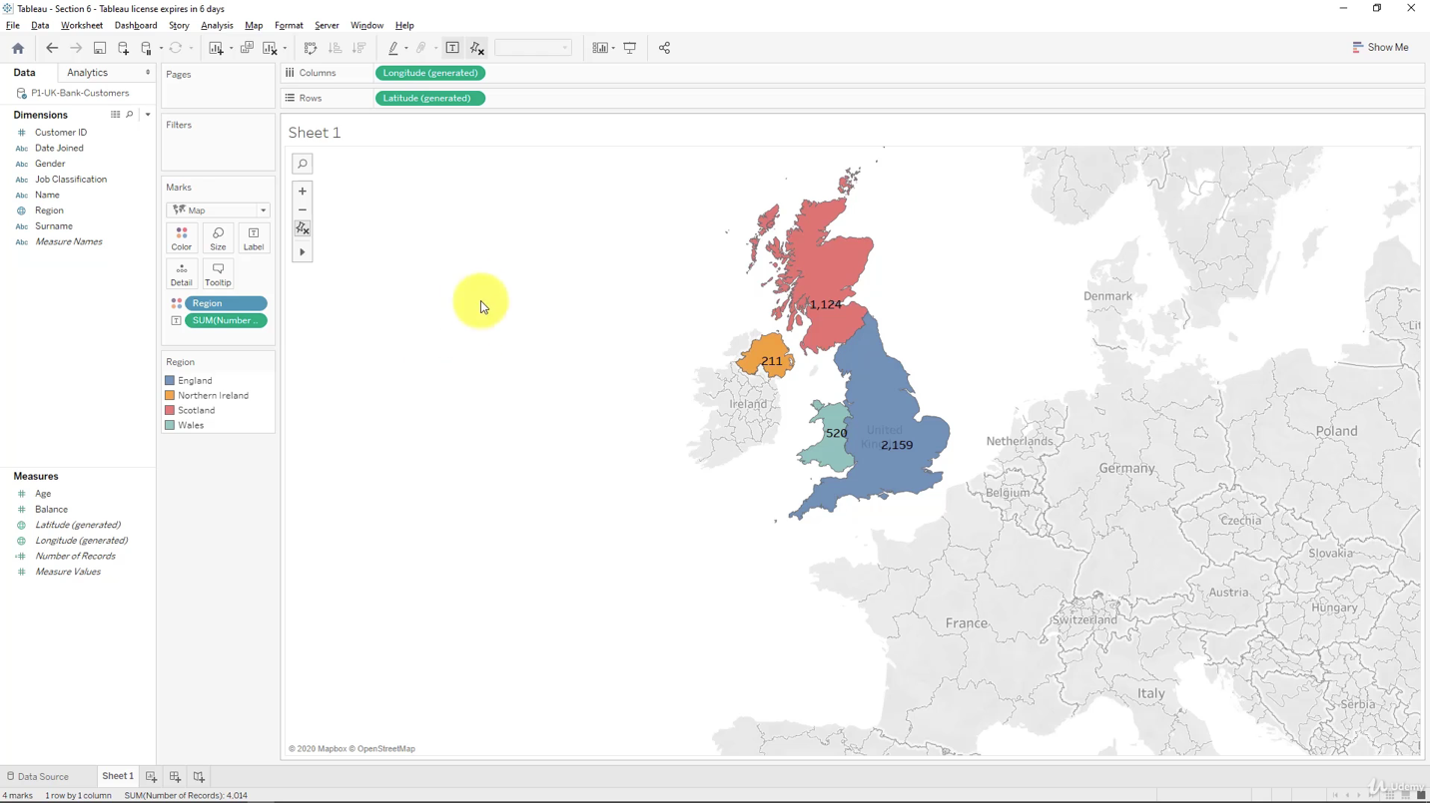

Creating Table calculations for Gender

Quick Table Calculation includes:

- Percent of Total

- Running Total

- Difference

- Percent Difference

- Rank

- Percentile

- Moving Average

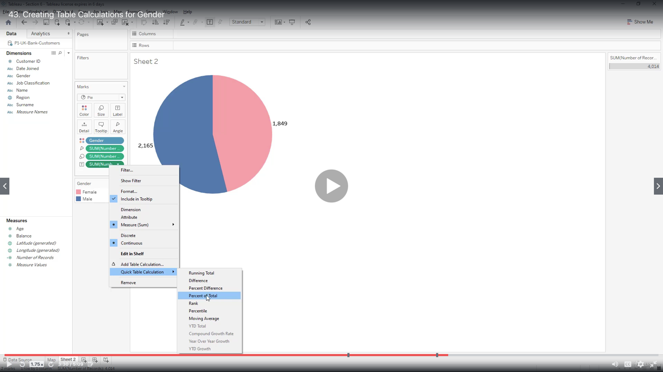

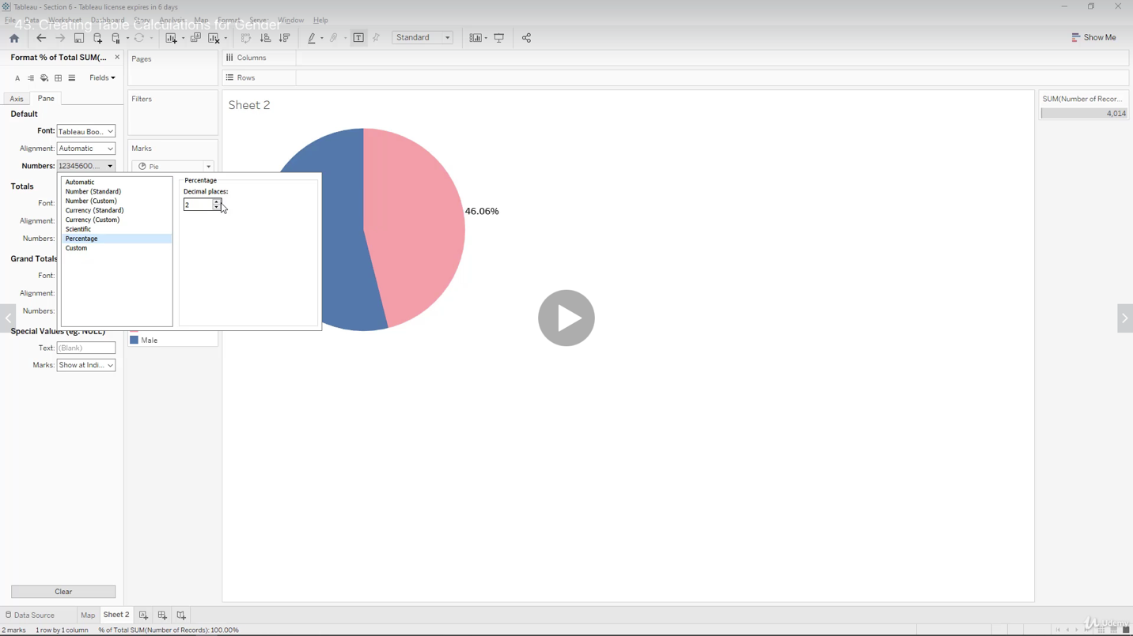

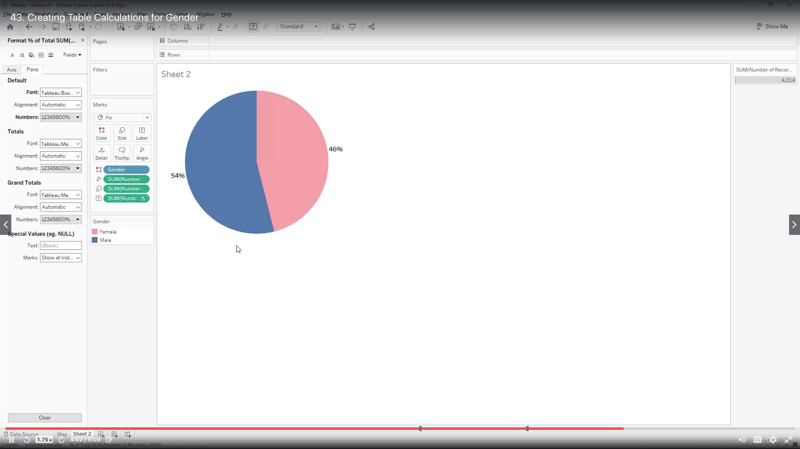

Creating Bins and Distributions for Age

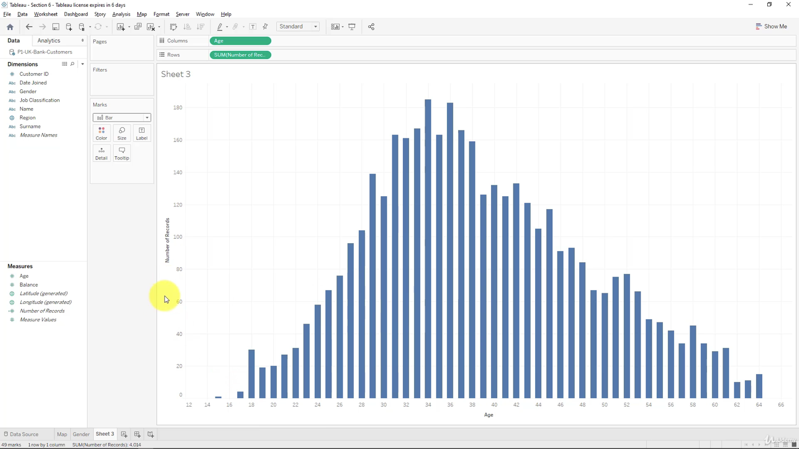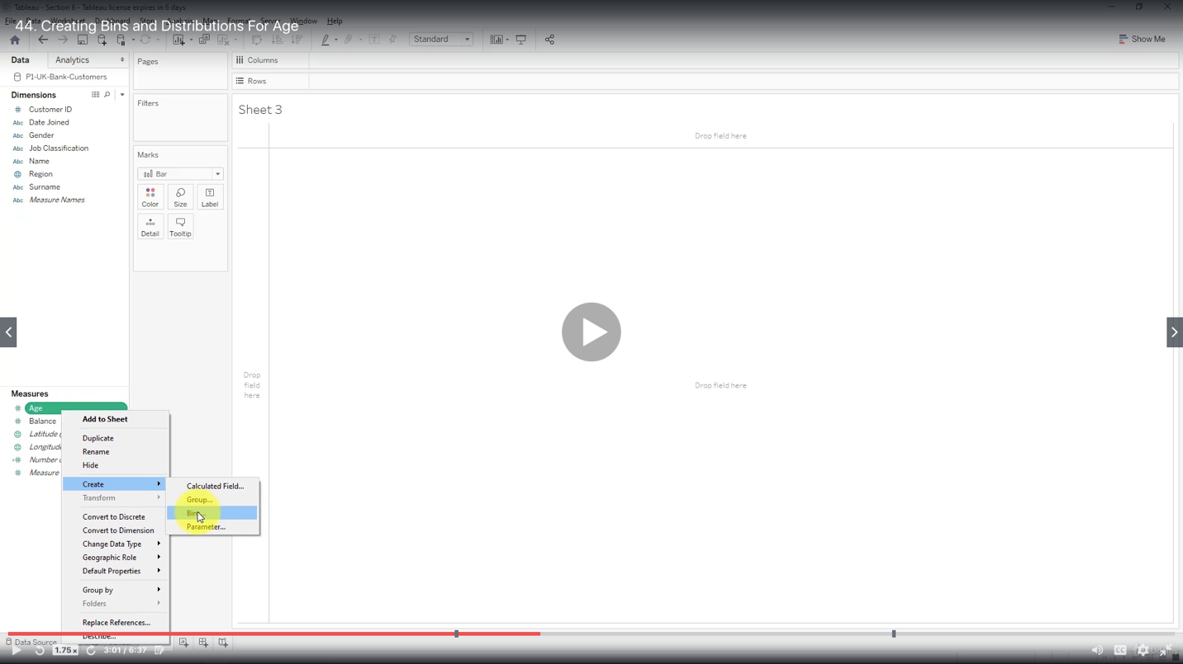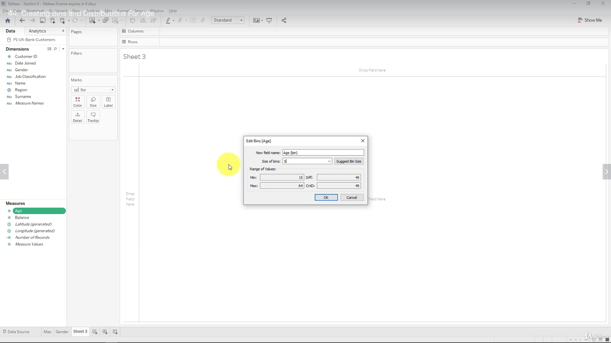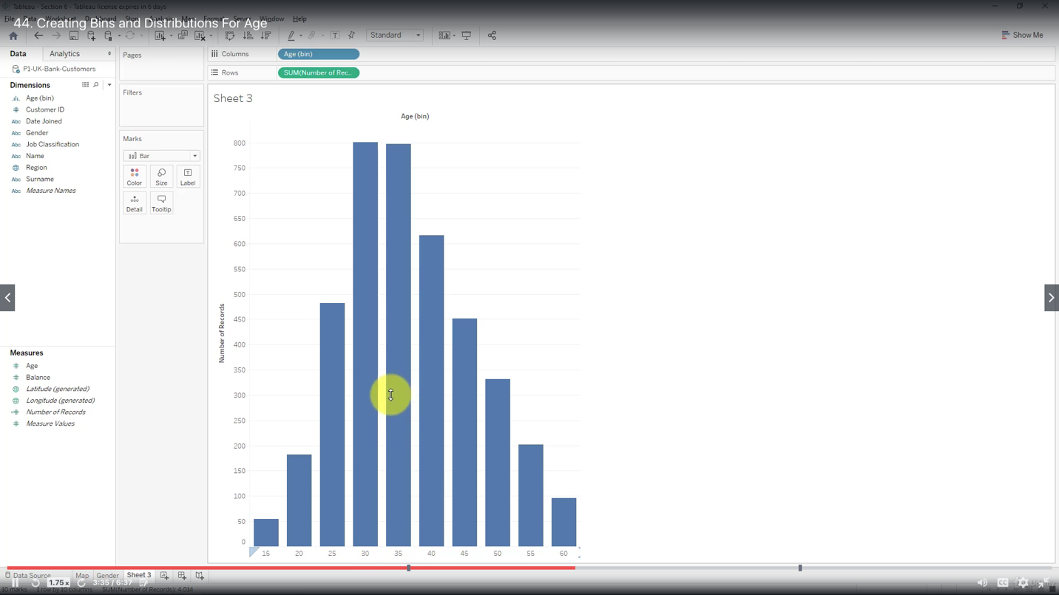

Show as percent of total

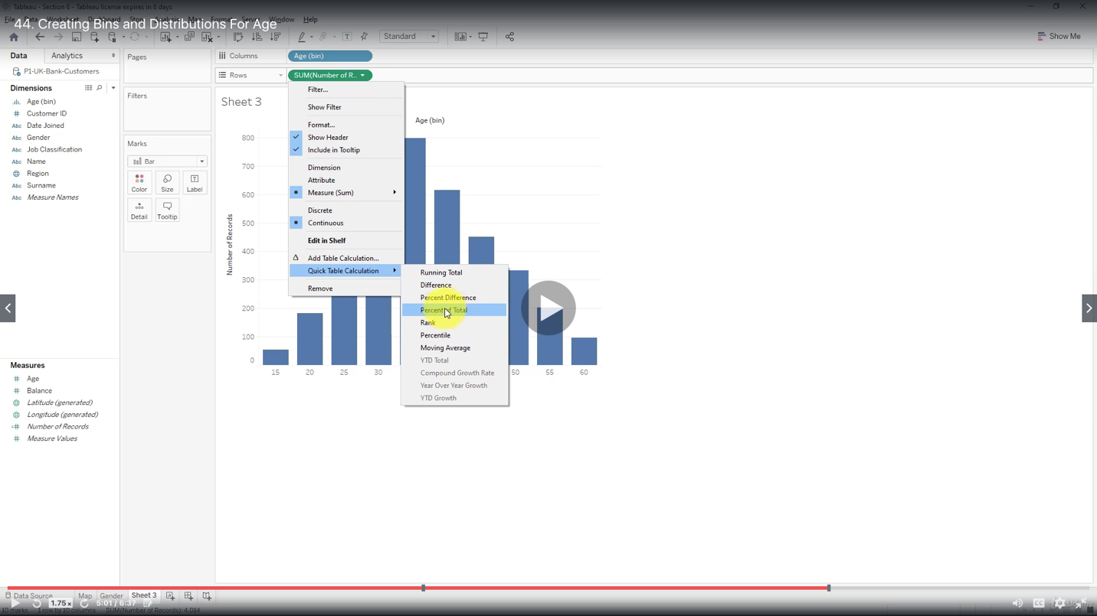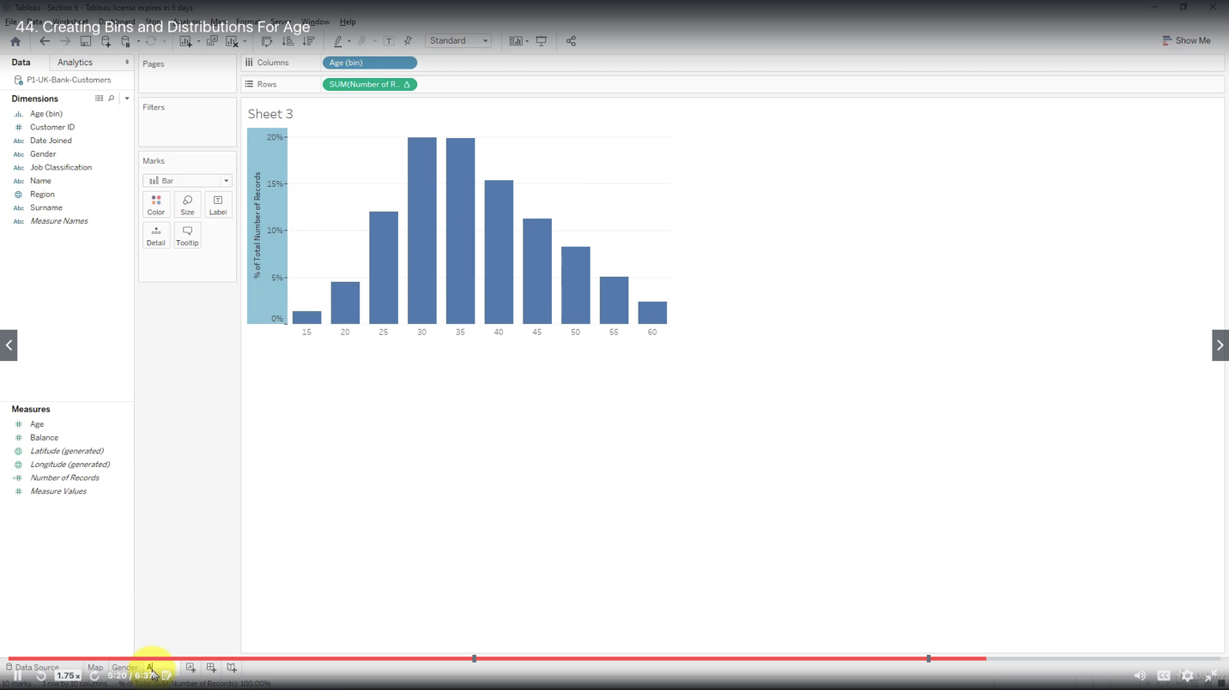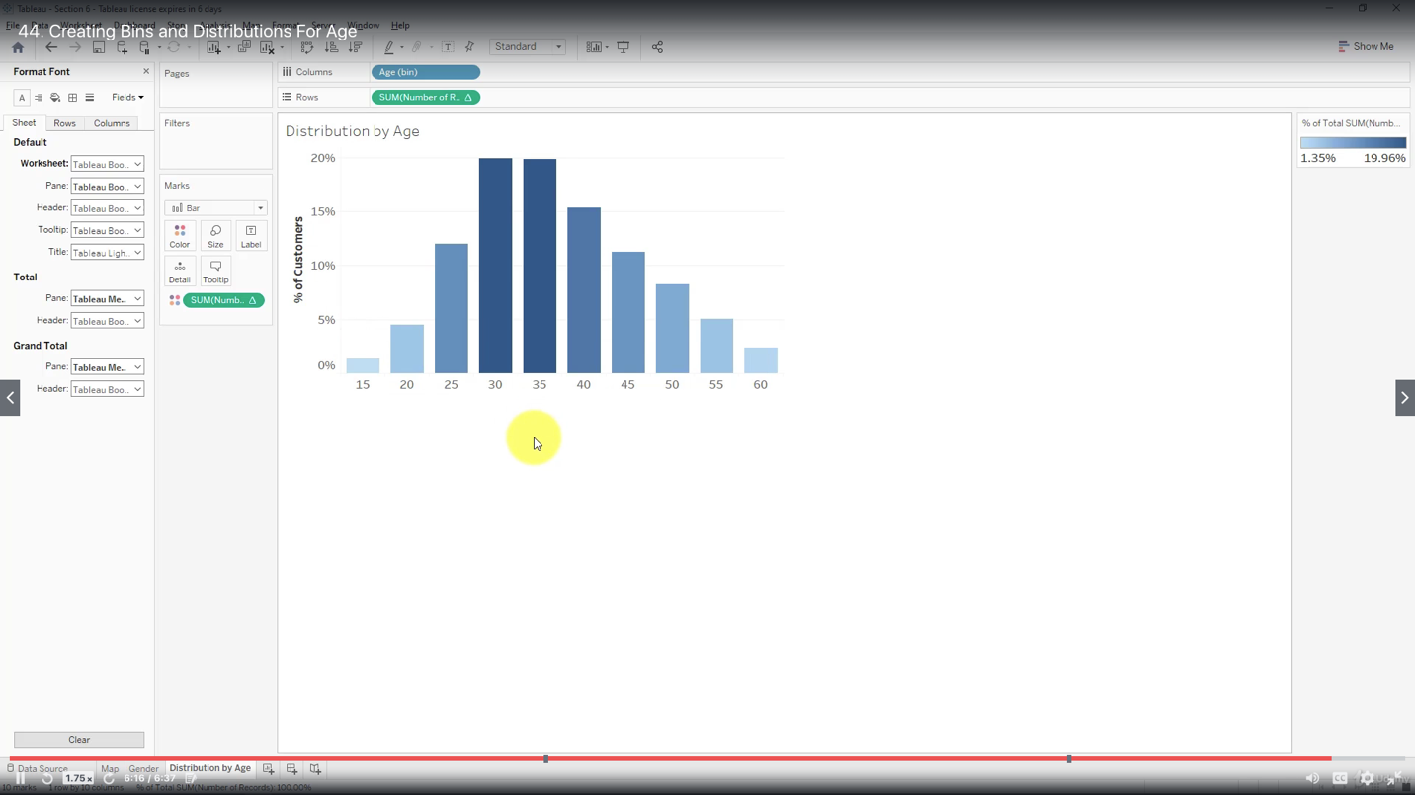

Leveraging the Power of Parameters

Type of allowable values for any parameter:

“All”

“List”

“Range”

Create a Balance Bin and show the histogram

Create a parameter

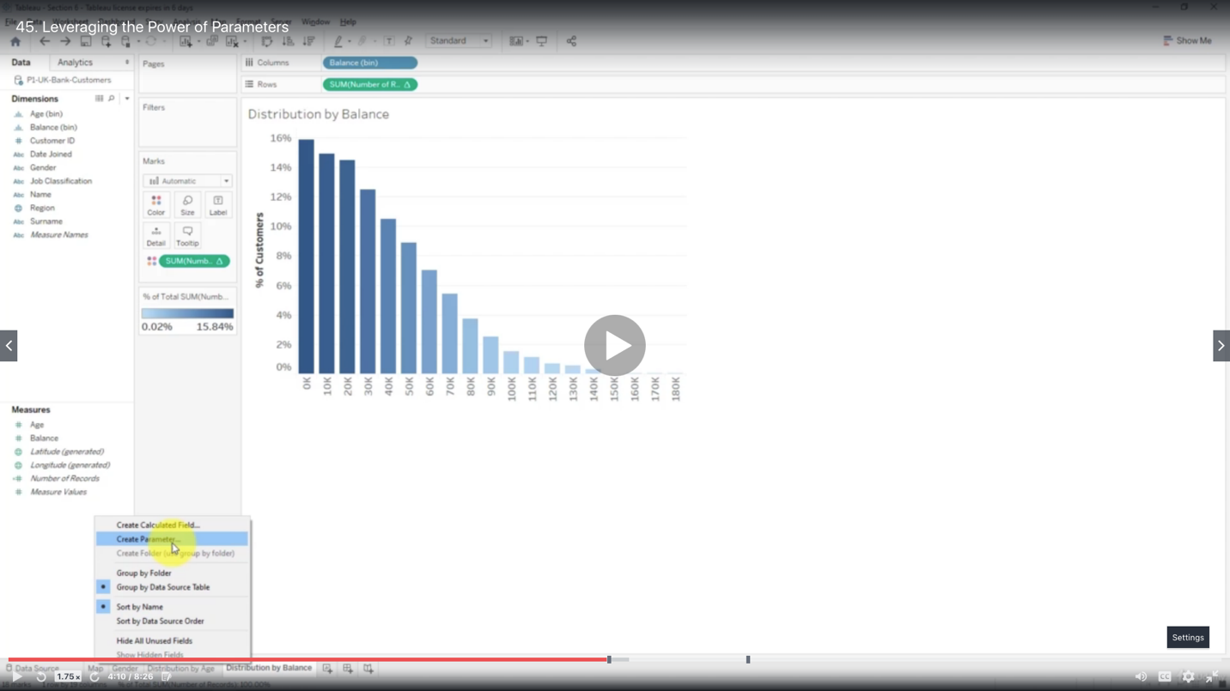

Name the parameter Balance Group

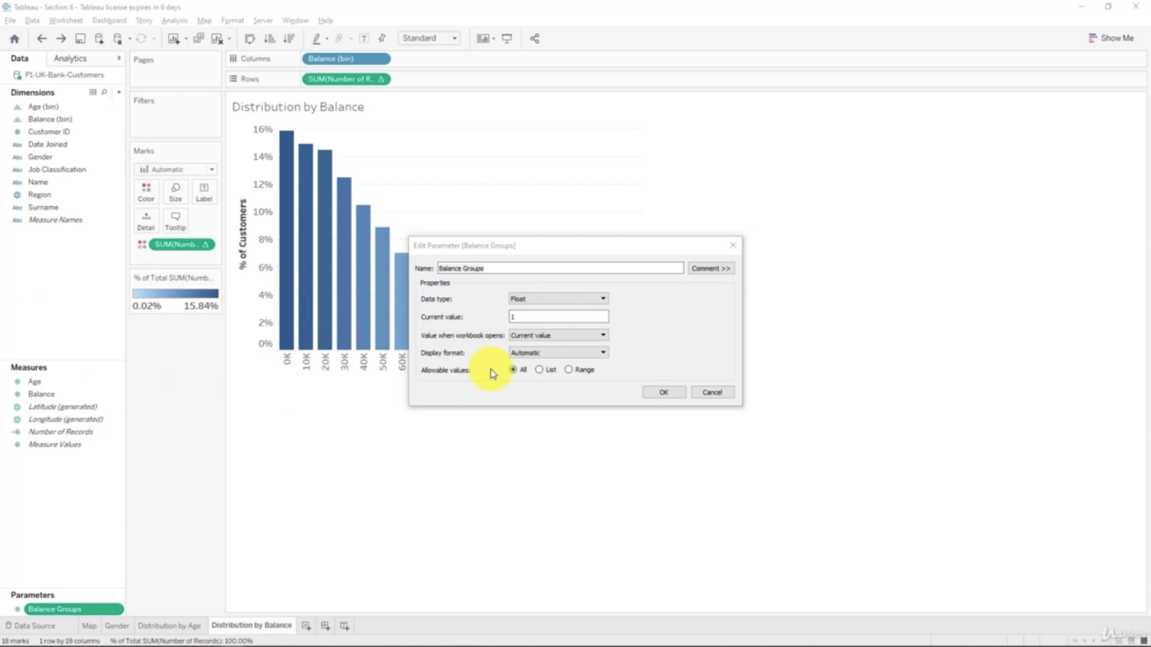

Decide datatype, value, range

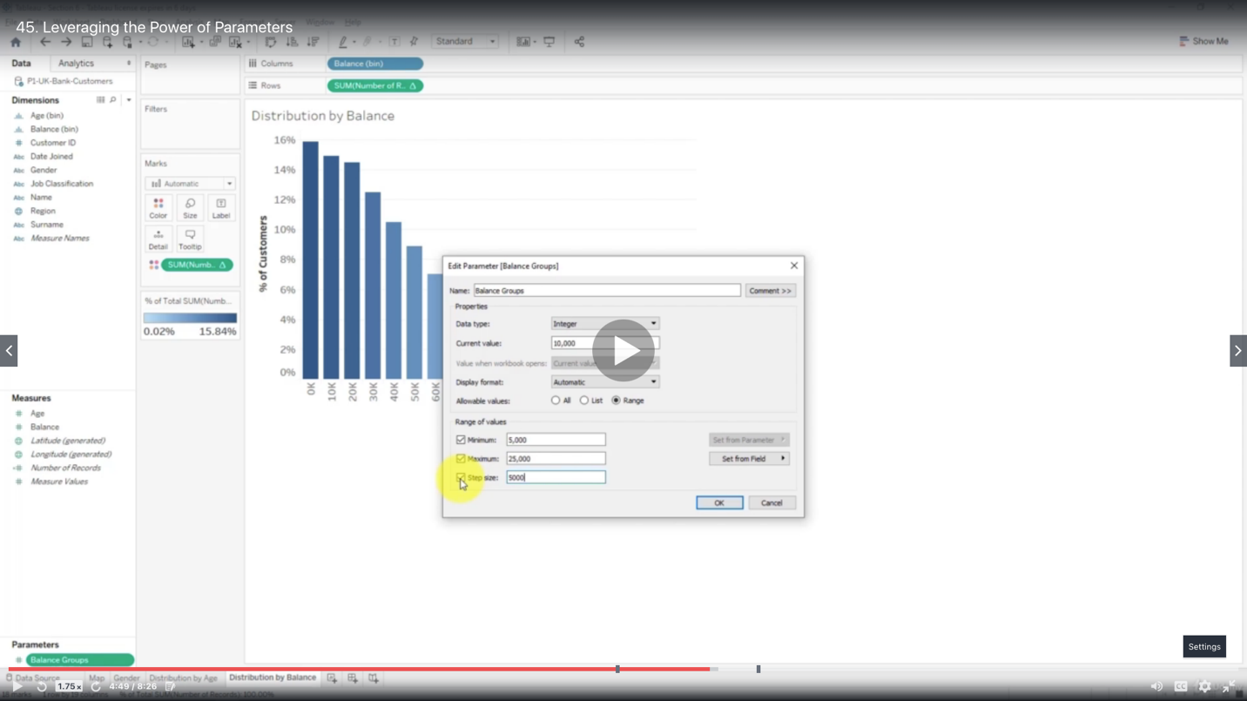

Left bottom corner: show parameter

Edit Balance Bin, for [Size of bins], select the new parameter Balance Group from the drop down menu, to connect the Balance Bin with the parameter Balance Group

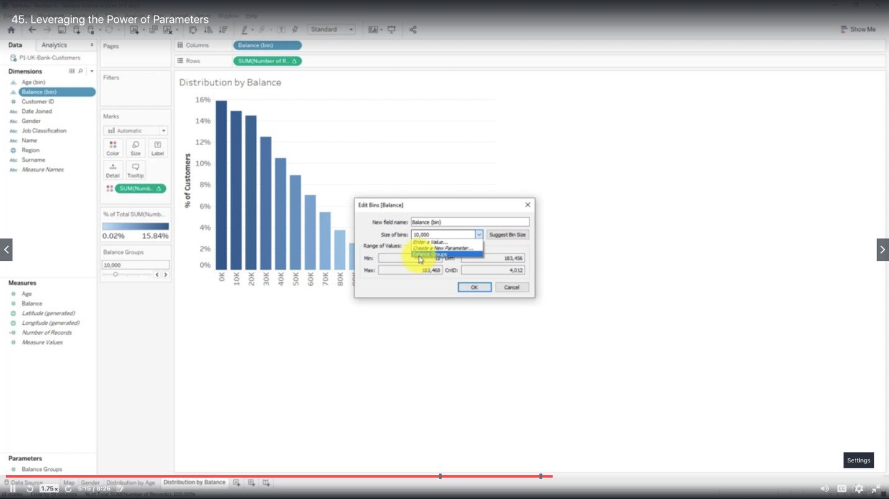

Control bins with the new parameter

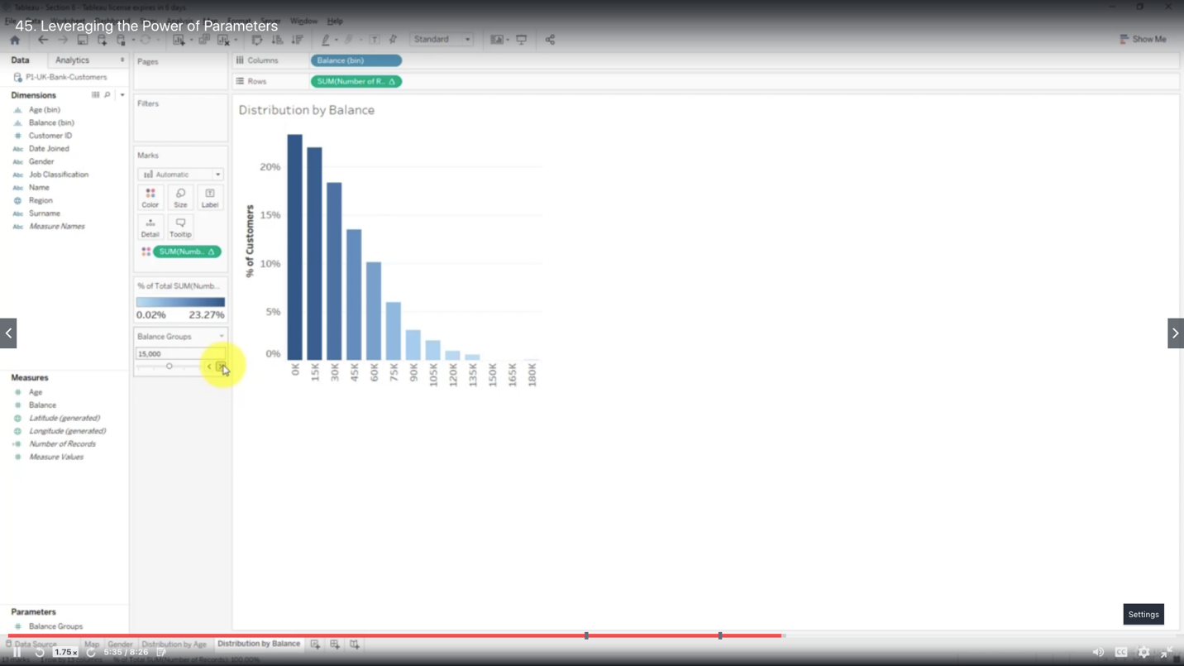

Creating a Tree Map Chart

The main visual element of a treemap is called “Box”

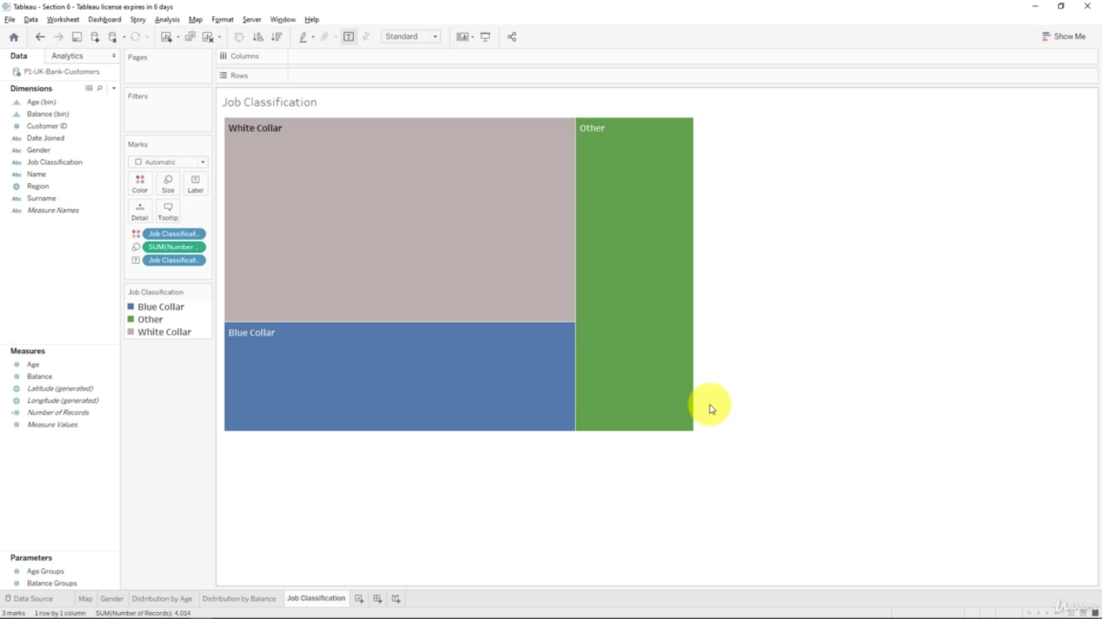

Creating a Customer Segmentation Dashboard

- To understand how customers are segmented across different geographies

- To understand how customers are segmented across different demographics

- To deliver a better customer experience making it tailored and relevant

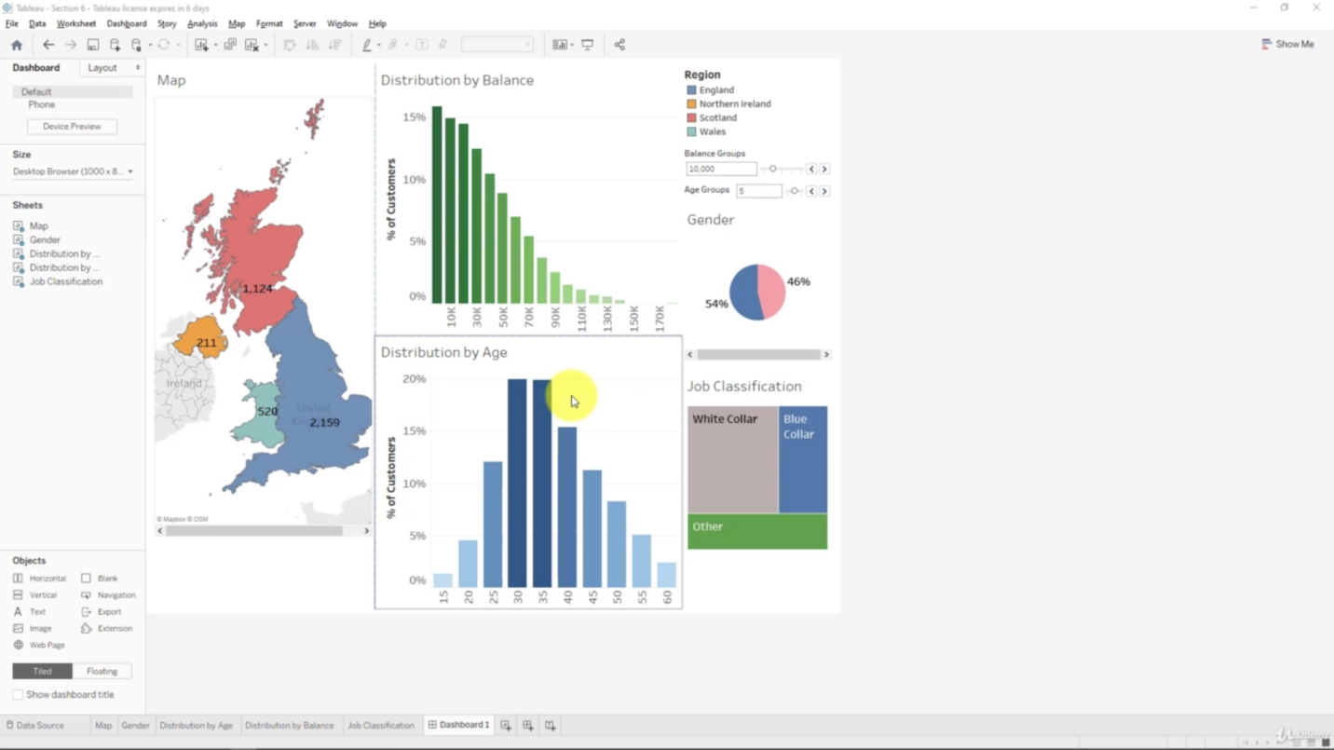

Advanced Dashboard Interactivity

With actions

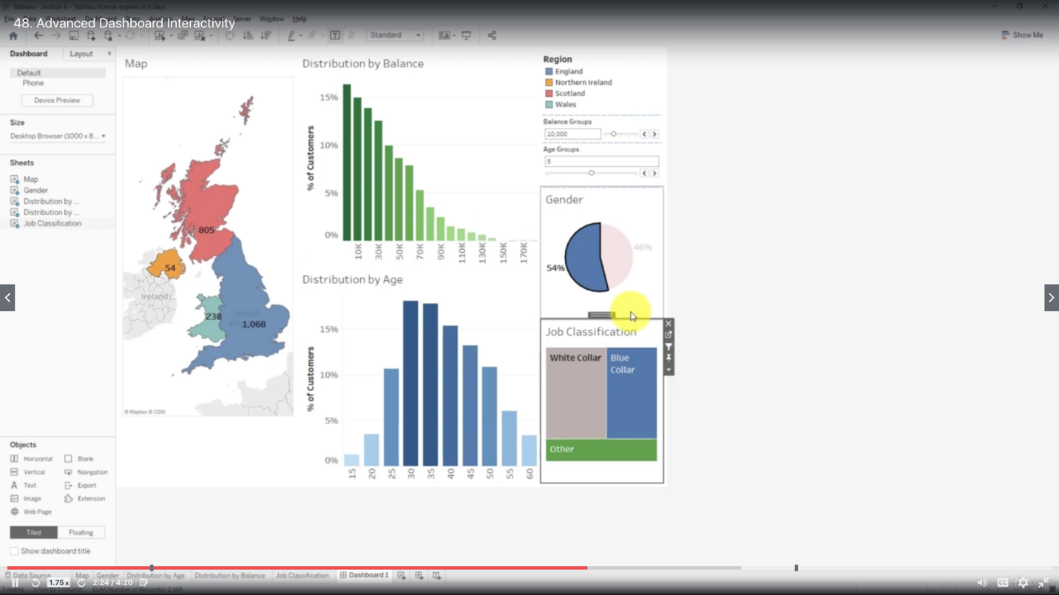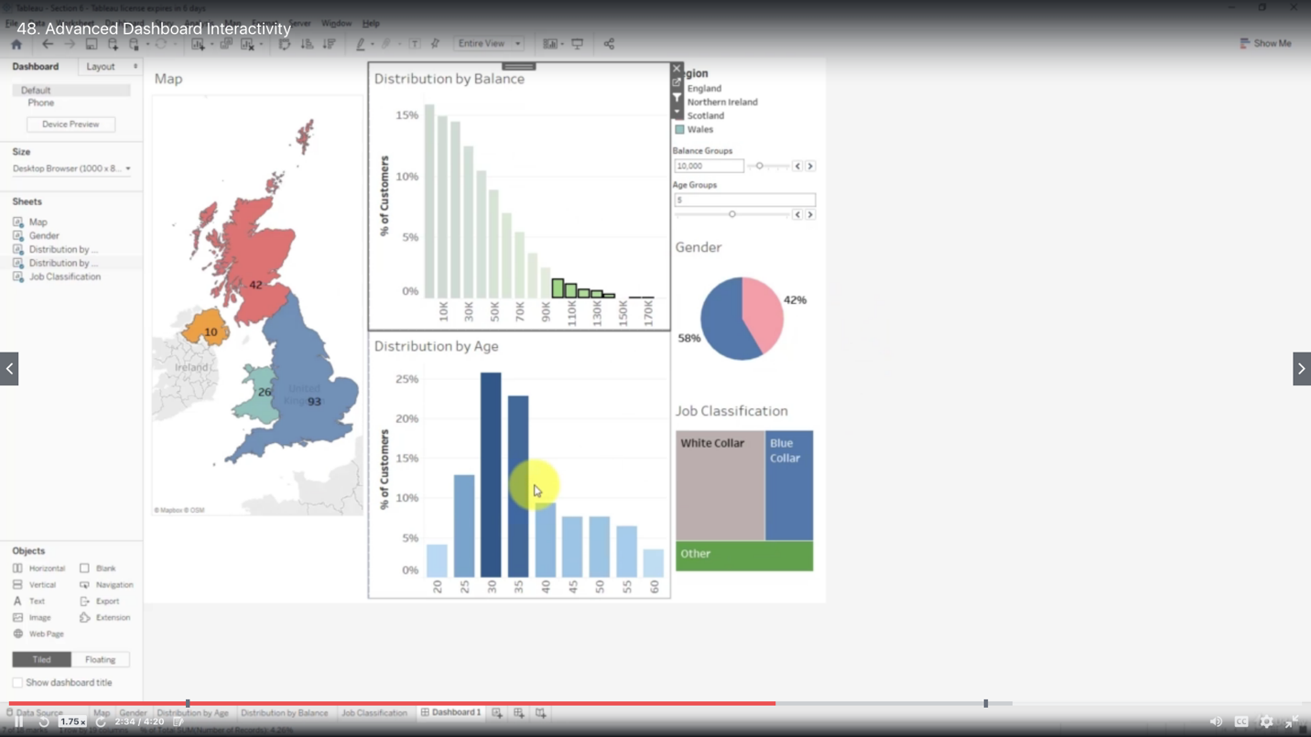

Hide tooltips

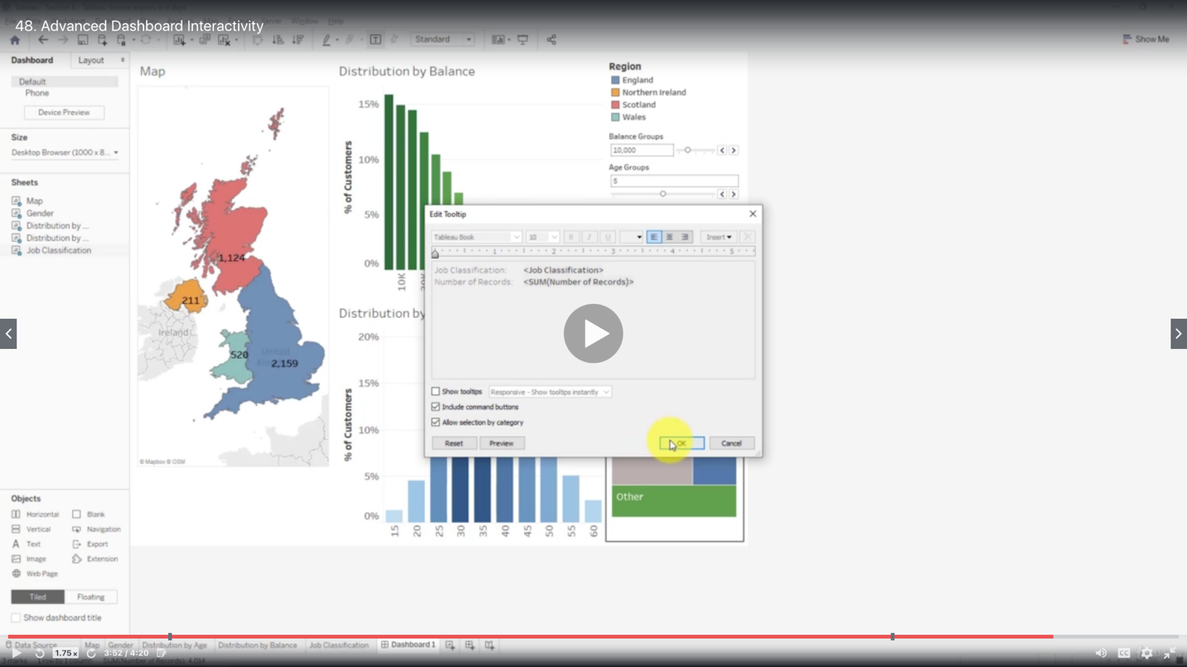

Creating a Storyline

Both worksheets and dashboards can be used as pages in a storyline, but cannot be combined on one page

When you change the value of a parameter on one page of the storyline, it does not change on all other pages of that storyline

